**Abstract**

Owing to the increasing interest in models from the Classical Equilibrium Thermodynamics that started from an ideal Otto cycle we were capable to fulfil several efficiencies closer to that of real spark-ignition engines. In addition, we had to deal with many practical points, also we had to elect, for each sub-model which one could be the most adequate for our purposes. This text is interested in understanding the physical, chemical, and engineering basis of spark-ignition engines. The numerical computational capabilities of computer facilities will enable us to propose realistic models, then validate them by comparing them with real engine outputs. Additionally, we will estimate the sensitivity of the engine variables to several parameters.

**INTRODUCTION**

Perhaps the best-known engine in the world, nowadays, is the reciprocating internal combustion engine. Virtually every person who has driven an automobile or pushed a power lawnmower has used one. By far the most widely used internal combustion engine is the spark-ignition gasoline engine, which takes us to school, work, or on pleasure jaunts.

Practical heat engines have served mankind for over two and a half centuries. For the first 150 years, water, raised to steam was interposed between the combustion gases produced by burning the fuel and the work producing piston in-cylinder expander. It was Etienne Lenoir (1822-1900) who developed an early form of the reciprocating internal combustion engine. Gas and air were drawn into the cylinder during the first half of the piston stroke. The charge was then ignited with a spark, the pressure increased, and the burned gases then delivered power to the piston for the second half of the cycle.

A more successful development was introduced in 1876 by Nicolaus Otto (1832-1891), who is generally credited with the invention of the engine and with the statement of its theoretical cycle. It was an atmospheric engine that used the pressure rise resulting from the combustion of the fuel-air charge early in the outward stroke to accelerate a free piston and rack assembly so its momentum would generate a vacuum in the cylinder.

Atmospheric pressure then pushed the piston inward, with the rack through a roller clutch to the output shaft. Another important engine is a new form of the internal combustion engine that made the name Rudolf Diesel (1858-1913) famous. The diesel engine, the workhorse of the heavy truck industry, is widely used in industrial power and marine applications. It replaced the reciprocating steam engine in railroad locomotives about fifty years ago and remains dominant in the role today. Diesel’s concept of initiating combustion by injecting liquid fuel into air heated solely by compression permitted a doubling of efficiency over other internal combustion engines. Much greater expansion ratios, without detonation or knock.

The simulation of the physical process in engine combustion chambers has found increasing interest during recent years. To validate new design concepts through experimental work takes a long-time and high cost, especially during the prototype developing stage. The computer simulation techniques are a useful alternative way, provided that the simulation model is accurate and fast enough to execute. A quasi-dimensional model for engine combustion was first developed in the 1970 and still used more frequently than multi used more frequently than multi-dimensional simulations, However, there is an important distinction between the state of the multi-dimensional simulation of engine combustion and the direct numerical solution of the instantaneous governing equations. For combustion in engines, direct numerical simulation is not yet applicable due to the extensive and continuous progressive and spatial scales that must be considered, practical limitations on computation time and cost, and very limited possibility for experimental validation.

**There are main objectives in modeling engines:**

1. Improving our knowledge about the main physical and chemical ingredients which govern the functioning theories of engines.
2. To analyze the key parameters affecting engine design and operation. This could be especially valuable to provide guidelines for more rational and less expensive experimental development efforts.
3. To predict the sensitivity of the engine to several control variables that could lead to optimizing engine design, control, and operation.
4. To anticipate the effect of design innovations before their experimental development and testing in bench engines.

Models developed for internal combustion engines are usually divided into two main categories, depending on the physical basis that is used to state the basic equations. These are thermodynamic and fluid dynamic models. Within thermodynamic models, the terminology of (zero-dimensional) and multi-zone models are often used.

* Single-zone models are based on the conservation of mass and energy through the first law of thermodynamics and have no spatial resolution because all the thermodynamic properties are considered uniform, and one single control volume is taken.
* In multi-zone models, the combustion chamber is divided into several zones, with each zone possessing uniform thermodynamic properties.

The first law of thermodynamics is applied to each of these control volumes with appropriate boundary conditions. Further on, the mathematical equations form a set of ordinary differential equations whose independent variable is the time or the crank angle. We are more concerned with the single-zone (zero-dimensional models).

**Single-Zone (Zero-Dimensional) Models**

In these models, a general expression for the first law of thermodynamics is applied to an open system formed by fuel, air, and residuals sequentially for each stroke.

* In the strokes of (compression and expansion) the thermodynamic system can be considered as a closed one as the valves will be closed during them. On the other hand, while (intake and exhaust) strokes the mass flow through the valves is taken into account consequently, the system will be treated as an open system.
* Similarly, the chemical composition of the gas mixture is not analogous in all the strokes, since it may contain a fuel-air-residuals mixture (before combustion) or only residuals (after combustion).

In these models, all the thermodynamic properties are homogeneous in the considered control volume. This is the reason these models are also called zero-dimensional models.

**Combustion Models**

* In a spark-ignition engine, the combustion is initiated via the action of the spark plug discharge. Experimental work has demonstrated that at the start of combustion, the flame is a smooth surface with a roughly spherical kernel about 1 mm in diameter and grows for the next degrees with an approximately spherical shape. Also, this period is called the initial burning phase or flame-development region. During this stage, a small fraction of the mass is burned and the burning speed is close to the laminar flame speed.
* Several crank degrees after, the interaction of the flame with the

turbulent gas flow turns out a highly wrinkled and convoluted outer surface of the flame. Burning speed now becomes turbulent flame speed. This stage is known as the fat-burning phase of rapid burning region. After the end of the flame propagation, it is experimentally known that not all the fuel mass is burned according to many factors such as the air to fuel ratio used, and the instantaneous engine load. This last stage is the final burning phase.

* The combustion process determines the amount of heat release and its timing which in turn will influence all the other phenomena during engine operation, specifically that a combustion model can be used effectively to describe the cycle-to-cycle variability in engine operation.
* The rate of combustion depends strongly on the flow field in the combustion chamber. This flow field is always turbulent instead of laminar in real operating conditions. Turbulent flames evolve at speeds that are one order of magnitude higher than laminar flames.
* The practical need to simulate and develop engines has led to pragmatic approaches or models that can be incorporated into computer codes without excessive difficulties.

Experimental work over the past few years has revealed some basic peculiarities in the combustion processes associated with spark-ignition engines.

These characteristics can be very useful to develop and use new or existing approaches.

**They are summarized as follows:**

1. In spark-ignition engines, the charge (fuel, air, and residual gases) is gaseous and is approximately uniformly premixed.
2. Combustion does not take place at a constant volume, but it is related to the piston motion.
3. The volume of the oxidation zone where the main chemical reactions occur is small and provided that swirl and squish are not very strong, the averaged flame front can be approximated as a portion of the surface of a sphere. In consequence, for a given combustion chamber geometry and spark plug position, the spherical burning area, its volume, and the combustion chamber inner area wetted by the burned gases, can be calculated as functions of the flame radius.
4. The heat transfer to the cylinder walls is produced in the burned gas zone, so its calculation is associated with the estimation of the area wetted by the burned gases.
5. During combustion, the components in the combustion chamber can be separated into two zones consisting of burned and unburned gases. This is an important feature in the thermodynamic analysis of the combustion process.

**COMPUTATIONAL MODEL STRUCTURE**

The model was programmed in Matlab.

**Model input variables are:**

* Fuel: Isooctane and fuel with formula.
* Constants of the specific heat calculation for each species.
* Atmospheric pressure and temperature.
* Engine speed in RPM.
* Engine geometry.
* Spark timing in degrees.
* Combustion duration in degrees.
* Time step of the calculations.
* Compression ratio.
* Fuel-air equivalence ratio.

After reading the input variables, the model starts to run with the given time step data. Next, it verifies if valves are closed. So, the closed cycle starts until one of the valves opens, then the open cycle begins. Output variables are generated for every time step and recorded. After that, a new crank angle is selected and the process starts again.

**Output variables are:**

* The instantaneous volume of the stroke concerning crank angle.
* Instantaneous piston position with respect to crank angle.
* Instantaneous valve lift with respect to crank angle.
* Instantaneous valve area with respect to crank angle.
* Instantaneous in-cylinder pressure.
* Instantaneous in-cylinder temperature.
* Instantaneous rate of air drawn mass.
* Instantaneous mass inside the engine.
* Instantaneous volumetric efficiency.
* Instantaneous mole number inside the engine cylinder.

**equation used in the program**

$$\dot{{\dot{Q}}_{in}+\dot{{\dot{H}}_{in}}- \dot{{\dot{H}}_{out}-{(P}_{cy}*\frac{dv}{dt})}}=(\frac{dE}{dt})$$

Where:

$${\dot{Q}}_{in} :is the rate of heat realsed during combustion phenomenon .$$

${\dot{H}}_{in} :is the rate of enthalpy change for the drawn air$.

$${\dot{H}}_{out} :is the rate of enthalpy change for the exhaust products.$$

$${(P}_{cy}*\frac{dv}{dt}) :is the rate of work done on the piston.$$

$(\frac{dE}{dt})$: is the rate of change in the internal energy each time step.

$$E_{reactant}=[ \left[{(R}_{u}*N_{real})*[ \left(\left(a-1\right)T_{cy}\right)+\left(b{(T}_{cy})^2\right) +\left(c{(T}_{cy})^3\right)+\left(d{(T}_{cy})^4\right) ]\right]+E_{0 }]$$

$$E_{0}=N_{real}*X_{fuel}*{Ui7}_{fuel}$$

$$a=[\left(a_{fuel}* X_{fuel}\right)+\left(a_{o2}* X_{o2}\right)+\left(a_{n2}* X_{n2}\right)]$$

$$b=[\left(b_{fuel}* X_{fuel}\right)+\left(b_{o2}* X_{o2}\right)+\left(b_{n2}* X_{n2}\right)]$$

$$c=[\left(c* X_{fuel}\right)+\left(c_{o2}* X_{o2}\right)+\left(c_{n2}* X_{n2}\right)]$$

$$d=[\left(d_{fuel}* X_{fuel}\right)+\left(d_{o2}* X_{o2}\right)+\left(d_{n2}* X_{n2}\right)]$$

$$E_{product}=[ \left[{(R}_{u}*N_{real})*[ \left(\left(a-1\right)T_{cy}\right)+\left(b{(T}_{cy})^2\right) +\left(c{(T}_{cy})^3\right)+\left(d{(T}_{cy})^4\right) ]\right]+E_{0 }]$$

$$E_{0}=N_{real}*{[(X}_{co2}*{Ui7}_{co2})+{(X}_{co}*{Ui7}_{co})+{(X}_{h2o}*{Ui7}_{h2o})]$$

$$a=[\left(a_{co2}* X_{co2}\right)+\left(a_{h2o}* X_{h2o}\right)+\left(a_{n2}* X_{n2}\right)+\left(a_{o2}* X_{o2}\right)+\left(a_{co}* X_{co}\right)]$$

$$b=[\left(b_{co2}* X_{co2}\right)+\left(b_{h2o}* X_{h2o}\right)+\left(b_{n2}* X_{n2}\right)+\left(b_{o2}* X_{o2}\right)+\left(b_{co}* X_{co}\right)]$$

$$c=[\left(c_{co2}* X_{co2}\right)+\left(c_{h2o}* X_{h2o}\right)+\left(c_{n2}* X_{n2}\right)+\left(c_{o2}* X_{o2}\right)+\left(c_{co}* X_{co}\right)]$$

$$d=\left[\left(d_{co2}* X_{co2}\right)+\left(d_{h2o}* X_{h2o}\right)+\left(d_{n2}* X_{n2}\right)+\left(d_{o2}* X_{o2}\right)+\left(d_{co}* X_{co}\right)\right]$$

$$α=\sin\left[ \left(\frac{θ_{intant}-θ_{BOC}}{{Δθ}_{combustion}}\right)* \frac{π}{2}\right]$$

$$α :which is the rate of products formation owing to the combustion phenomenon$$

$$E_{total}=[\left(\left(1-α\right)* E_{reactant}\right)+\left(α*E_{product} \right)]$$

$$X_{species}:is the mass fraction of the species to the total mixture$$

$$dt=\frac{Δθ}{6N}$$

Where N here is the engine speed (revolution per minute)

$$\dot{m}=C_{d}*A_{valve}*\sqrt[2]{(2ρ_{air}(P_{atm}-P_{cy}))}$$

$$\dot{H}=\dot{m}*C_{p}*T$$

$$m_{new}=m_{old}+\left(\dot{m}*dt\right)$$

$$N_{real}=m_{new} /(MW)$$

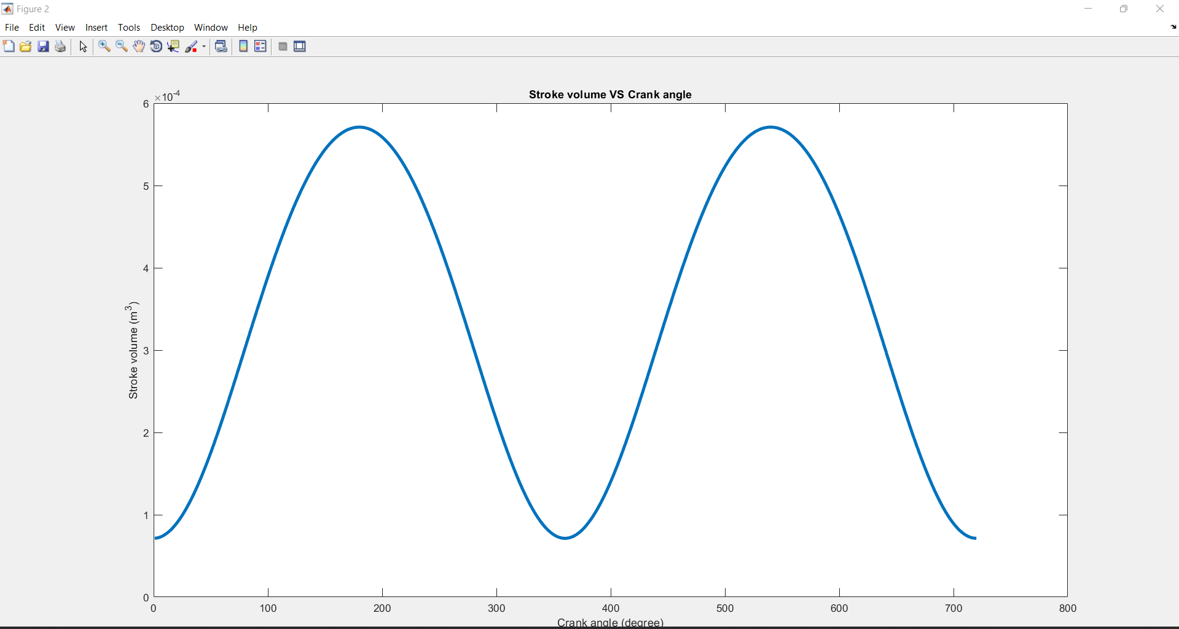**RESULTS**

This figure represents the relation between the stroke volume and the crank angle.

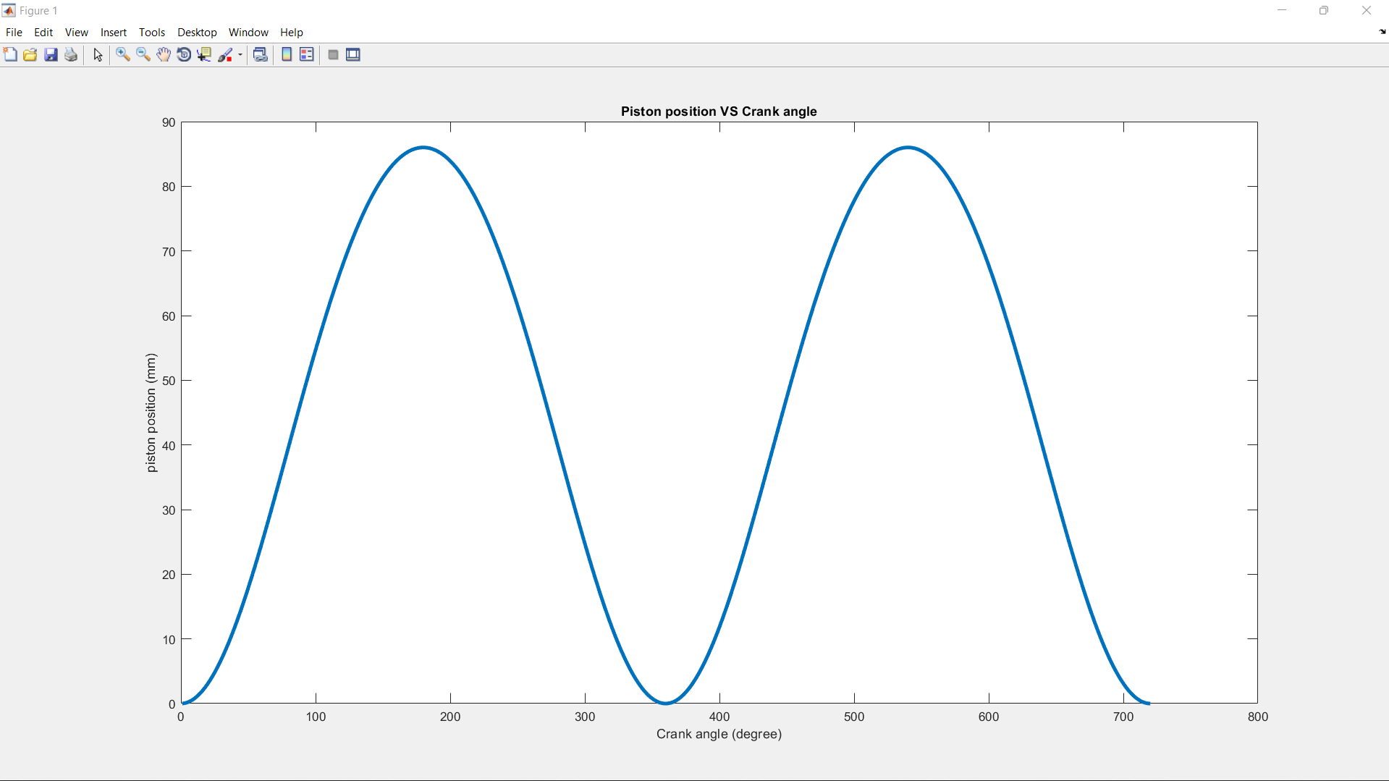

This figure represents the relation between the piston position and the crank angle.

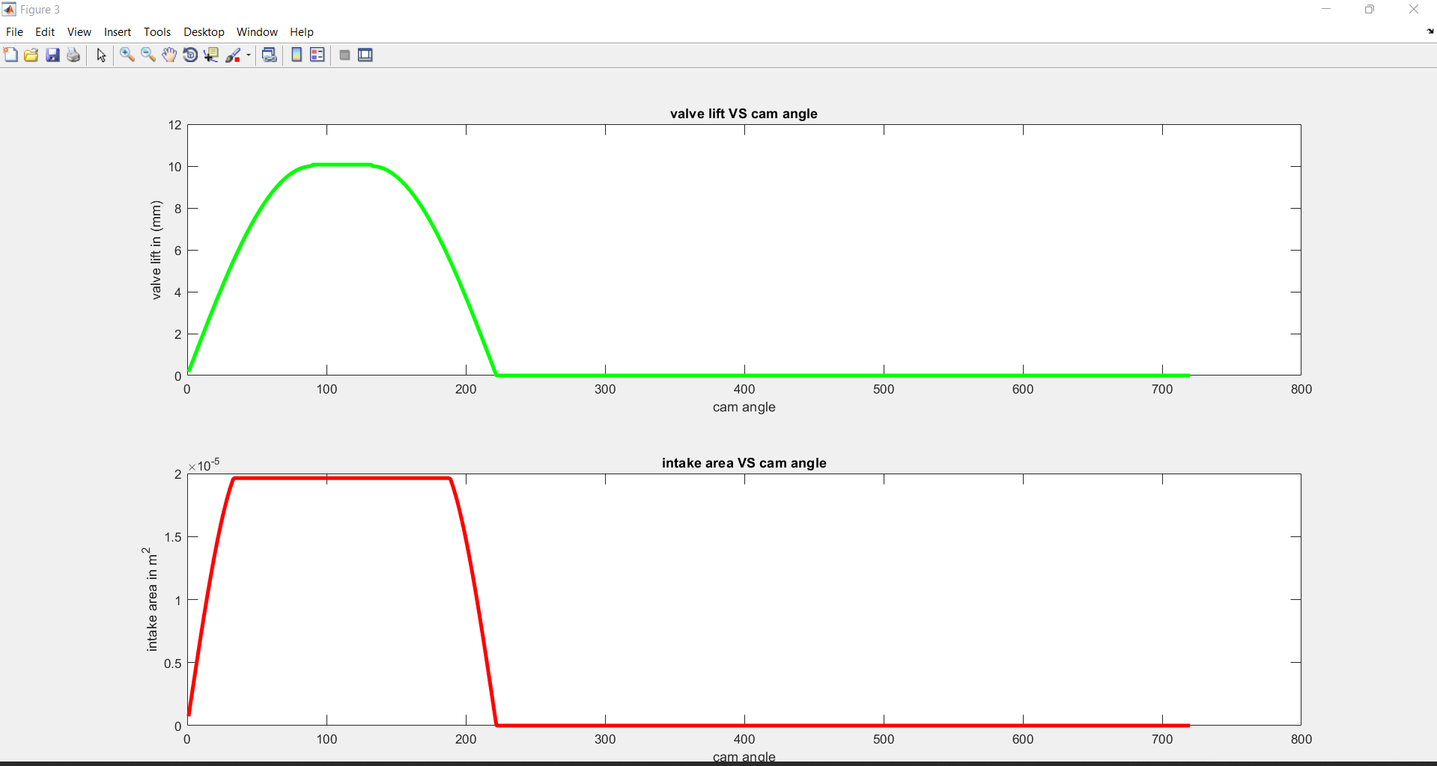

This figure represents the relation between the instantaneous valve lift and the crank angle. Also, the relation between the instantaneous intake valve area with respect to the crank angle.

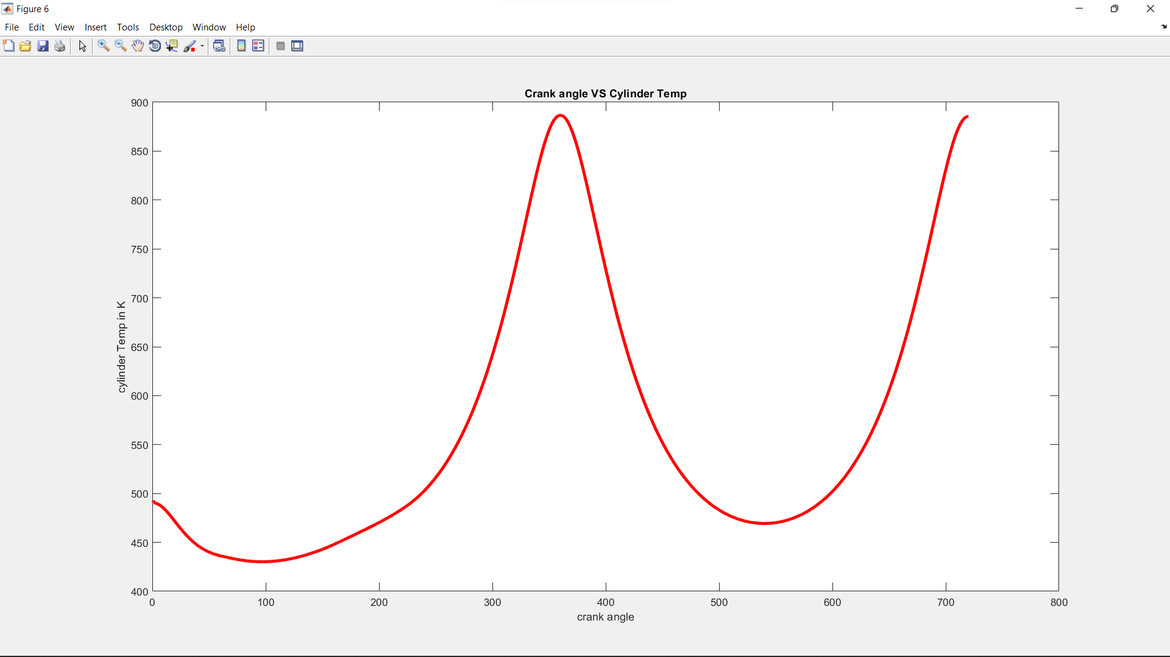

This figure represents the relation between the In-cylinder temperature during the cold mode and the crank angle.

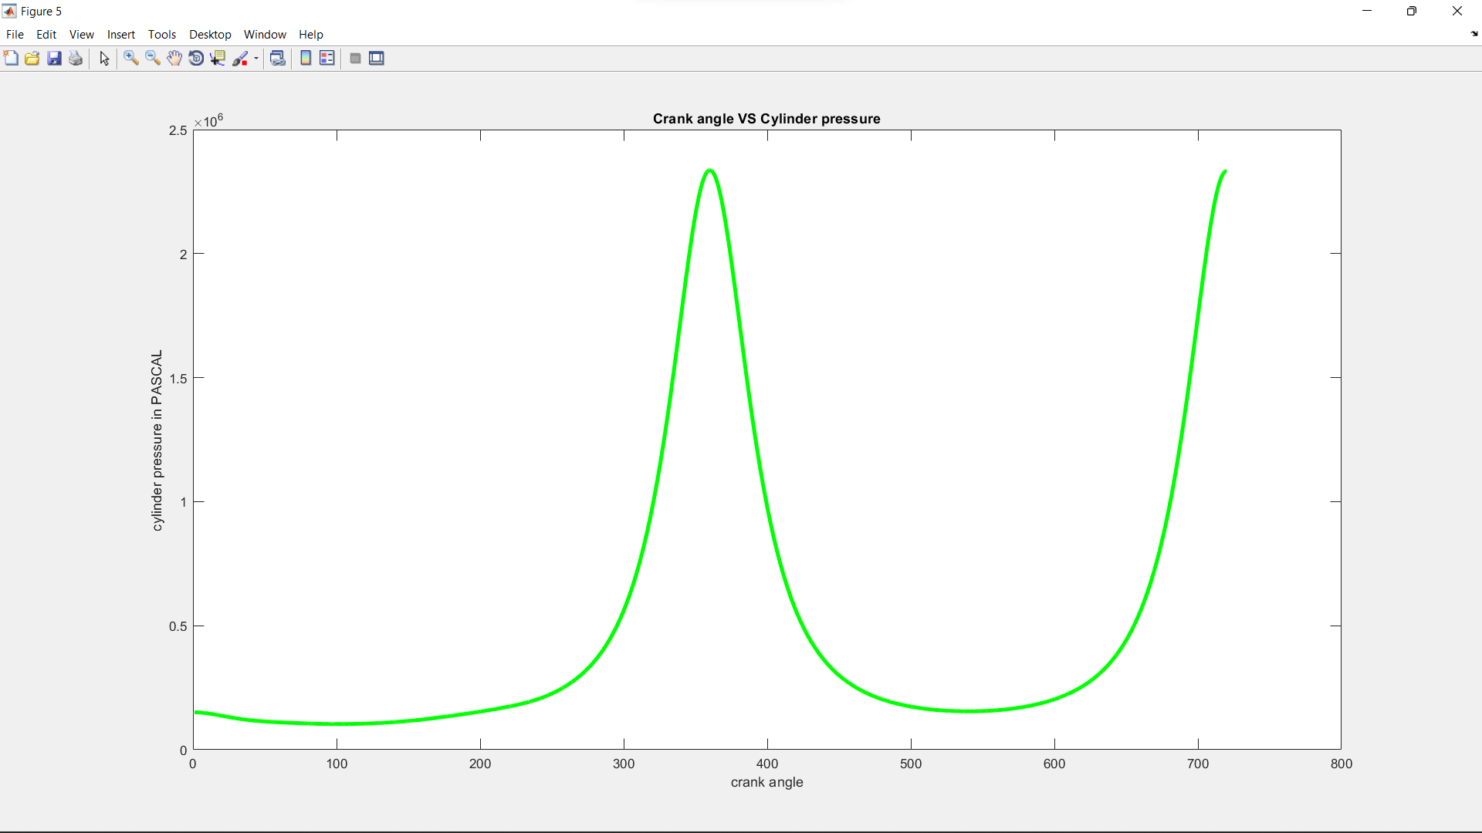

This figure represents the relation between the In-cylinder pressure during the cold mode and the crank angle.

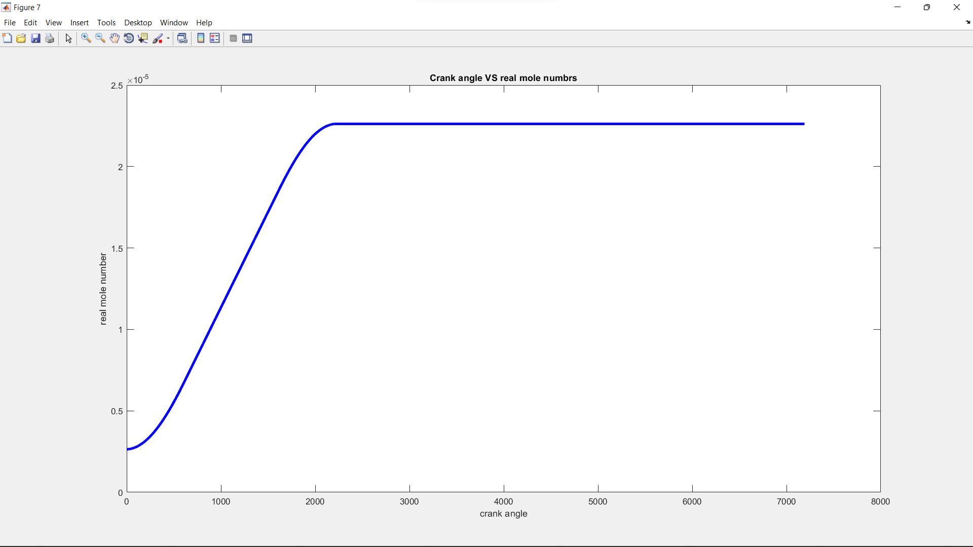

This figure represents the relation between the instantaneous real mole number during the cold mode and the crank angle.

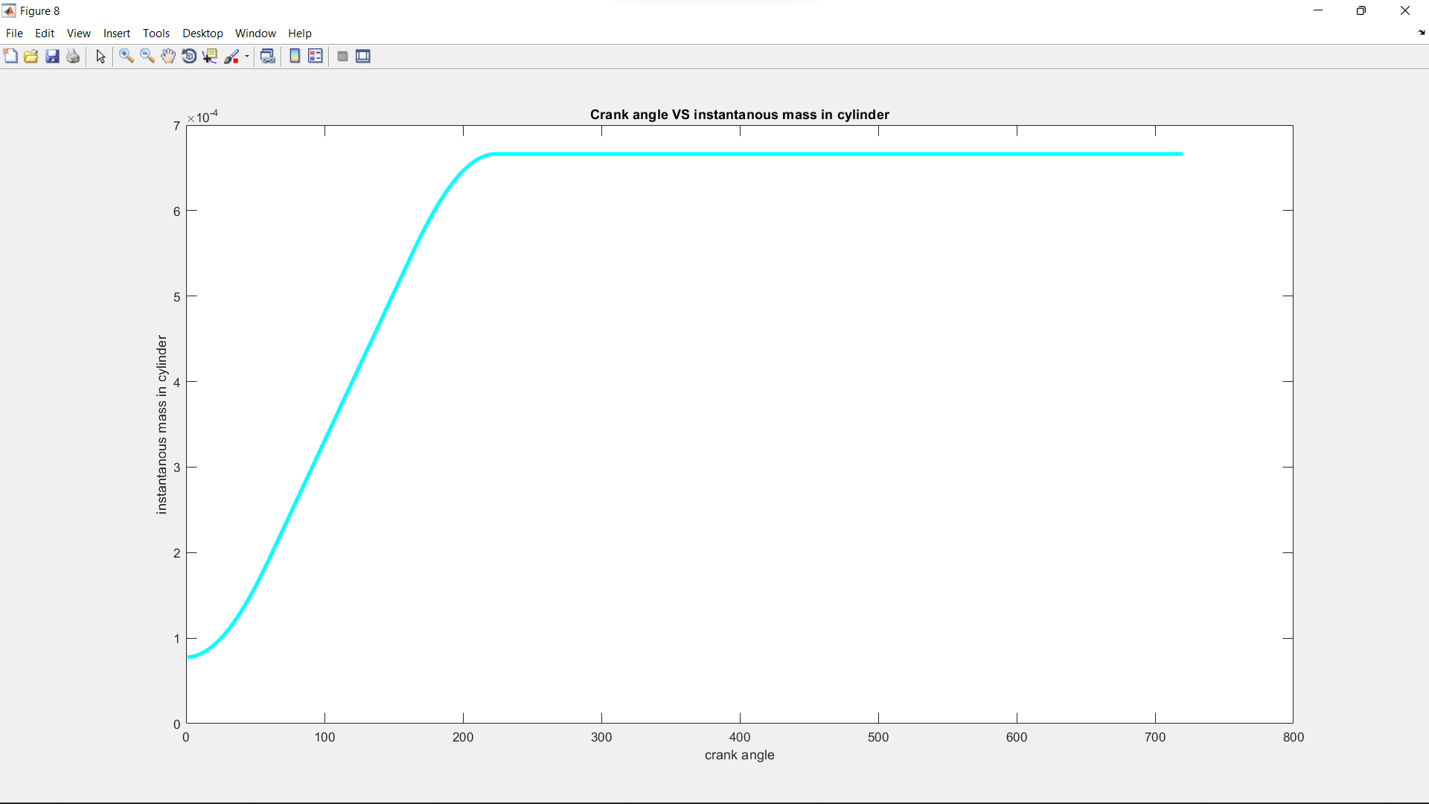

This figure represents the relation between the Instantaneous air mass drawn into engine cylinders during the cold mode and the crank angle.

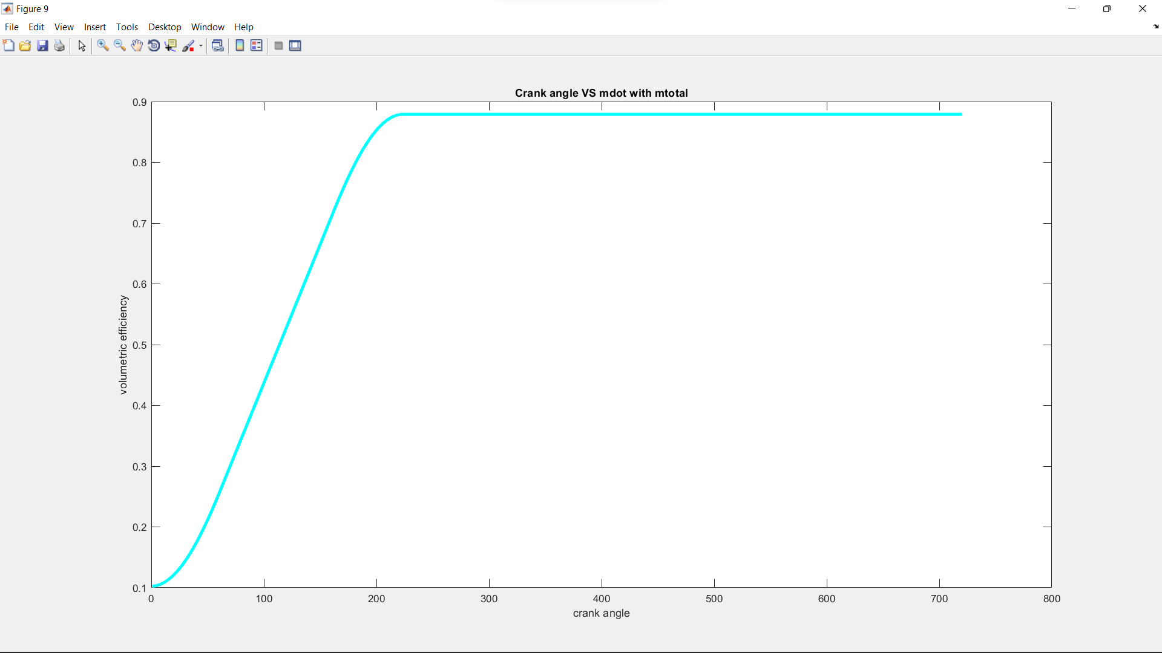

This figure represents the relation between the Instantaneous volumetric efficiency during the cold mode and the crank angle.

**CODE**

**Alfa angle subroutine**

d_theta=0.1;

%________________assumptions__________________

theta_ign=300; %crank angle begining of igntion

delta_theta_ign=20; %delata crank angle of igntion delay

boc=theta_ign+delta_theta_ign; %crank angle beginging of combustion

delta_theta_comb=60; %delata crank angle of combustion

eoc=boc+delta_theta_comb; %crank angle end of combustion

%______________usful variables__________________

%____________variables to store data_________________

theta_crank=[1:d_theta:720]; % this matrix is used to store the values of crank angle

a=zeros(1,length(theta_crank)); % this matrix is used to store the alfa angle value

% theta_crank_length=length(theta_crank)

% a_length=length(a)

j=(boc*(1/d_theta));

%__________________main program_______________________

for i=(boc*(1/d_theta)):(eoc*(1/d_theta))

b=deg2rad(((abs(theta_crank(j)-boc))/delta_theta_comb)*90);

a(i)=sin(b);

j=j+1;

end

for i=((eoc)*(1/d_theta)):((720*(1/d_theta))-(1/d_theta))

a(i)=1;

end

a(a_length)=1;

% theta_crank_length=length(theta_crank)

% a_length=length(a)

plot(theta_crank,a,'r','LineWidth',4);

title('alfa_combustion VS crank angle');

xlabel('Crank_angle');

ylabel('Alfa');

**combustion equation subroutine**

% THIS SCRIPT IS FORMED TO CALCULATE THE MOLE NUMBERS (RELATIVE & REAL) OF

% BOTH REACTANTS AND PRODUCTS

a1f=1.13711;a2f=1.4553*10^-2;a3f=-2.95876*10^-6;a4f=0;

a1o2=3.25304;a2o2=6.5235*10^-4;a3o2=-1.49524*10^-7;a4o2=1.5389*10^-11;

a1n2=3.3443;a2n2=2.9426*10^-4;a3n2=1.953*10^-9;a4n2=-6.574*10^-12;

a1co2=3.09590;a2co2=2.73114*10^-3;a3co2=-7.8854*10^-7;a4co2=8.66002*10^-11;

a1h2o=3.74292;a2h2o=5.65590*10^-4;a3h2o=4.95240*10^-8;a4h2o=-1.81802*10^-11;

a1co=3.317;a2co=3.76970*10^-4;a3co=-3.22080*10^-8;a4co=-2.19450*10^-12;

%___________given values______________________

n_cum=3; %CnHm of fuel

m_cum=8;

lamda_cum=1; %amout of excees air of more air

%___________constant calculated vlues_________

X_air=(n_cum+(m_cum/4)); %amount of theortical air

b_h2o=m_cum/2; %amount of H2O

%___________changing values___________________

a_co2=0; %CO2 constant

e_o2=0; %excess O2 constant

d_co=0; %CO constant in case of incomblite comdustion

N_r_r=0; %relative mole number of the reactants

N_p_r=0; %relative mole number of the products

N_r_re=0; %real mole number of the reactants

N_p_re=0; %real mole number of the products

xf=0; %fuel mole fraction

xo2_r=0; %oxcgen mole fraction of the reactants

xn2_r=0; %nitrogen mole fraction of the reactants

xa=0; %CO2 mole fraction of the products

xb=0; %H2O mole fraction of the products

xd=0; %CO mole fraction of the products

xe=0; %oxcgen mole fraction of the products

xn2_p=0; %nitrogen mole fraction of the products

%___________calculating other varaibles_______

if(lamda_cum==1)

%this is a theortical mixture (e=d=0)

e_o2=0;d_co=0;

a_co2=n_cum;

elseif(lamda_cum>1)

%this is excess air combustion(d=0)

d_co=0;

a_co2=n_cum;

e_o2=(X_air*lamda_cum)-a_co2-(b_h2o/2);

else

%this is an incomblite combustion(e=0)

e_o2=0;

d_co=2*(n_cum+(b_h2o/2)-(X_air*lamda_cum));

a_co2=n_cum-d_co;

end

N_r_r=1+(4.76*(X_air*lamda_cum));

N_p_r=a_co2+b_h2o+d_co+e_o2+(3.76*(X_air*lamda_cum));

xf=1/N_r_r;

xo2_r=(X_air*lamda_cum)/N_r_r;

xn2_r=(X_air*lamda_cum*3.76)/N_r_r;

xa=a_co2/N_p_r;

xb=b_h2o/N_p_r;

xd=d_co/N_p_r;

xe=e_o2/N_p_r;

xn2_p=(3.76*X_air*lamda_cum)/N_p_r;

disp('X=');

disp(X_air);

disp('Lamda=');

disp(lamda_cum);

disp('a=');

disp(a_co2);

disp('b=');

disp(b_h2o);

disp('e=');

disp(e_o2);

disp('d=');

disp(d_co);

disp('relative mole number of reactants=');

disp(N_r_r);

disp('relative mole number of products=');

disp(N_p_r);

a_equ=((a1f*xf)+(a1o2*xo2_r)+(xn2_r*a1n2))

b_equ=((a2f*xf)+(a2o2*xo2_r)+(a2n2*xn2_r))

c_equ=((a3f*xf)+(a3o2*xo2_r)+(a3n2*xn2_r))

d_equ=((a4f*xf)+(a4o2*xo2_r)+(a4n2*xn2_r))

a_t=((a1f*xf)+(a1o2*xo2_r)+(xn2_r*a1n2));

a_tr=((a_t*N_r_r)-1);

b_tr=((a2f*xf)+(a2o2*xo2_r)+(a2n2*xn2_r))*N_r_r;

c_tr=((a3f*xf)+(a3o2*xo2_r)+(a3n2*xn2_r))*N_r_r;

d_tr=((a4f*xf)+(a4o2*xo2_r)+(a4n2*xn2_r))*N_r_r;

ap_tr=((a1co2*xa)+(a1h2o*xb)+(a1n2*xn2_p));

bp_tr=((a2co2*xa)+(a2h2o*xb)+(a2n2*xn2_p));

cp_tr=((a3co2*xa)+(a3h2o*xb)+(a3n2*xn2_p));

dp_tr=((a4co2*xa)+(a4h2o*xb)+(a4n2*xn2_p));

e0_r=N_r_r*xf*-9-0.90510*10^8;

e0_p=(N_p_r*xa*-3.9364*10^8)+(N_p_r*xb*-2.39225*10^8);

disp('Xf=');

disp(xf);

disp('xo2_r=');

disp(xo2_r);

disp('xn2_r=');

disp(xn2_r);

disp('xco2=');

disp(xa);

disp('xh2o=');

disp(xb);

disp('xn2 pro=');

disp(xn2_p);

e_r=(8314*((a_tr*300)+(b_tr*300^2)+(c_tr*300^3)+(d_tr*300^4)-300));

e_r_t=e_r-e0_r;

z=(e_r_t+e0_p)/8314;

**cam subroutine**

% clear all;clc;

max_area=0;

max_vlift=0;

p_area=0.0058; %in m^2

% d_theta=0.1;

%____________________assumpations_____________________________________%

rb_cam=10;%radious of base circle

rn_cam=8; %radious of nosie circle

r_cam=8; %radious of cam follower

dp_cam=30; %radious of intake port

%____________________martsises________________________________________%

a_cam=1:d_theta:720;%this matrix is uesed to store the theta value in degree

b_cam=1:d_theta:720;%this matrix is uesed to store the theta value in radians

% l=1:d_theta:720;

ll_cam=zeros(1,(length(a_cam)));% this matrix to store the valve lift

aiv_cam=zeros(1,(length(a_cam)));%this matrix to store the instantions valve area

av_cam=zeros(1,(length(a_cam)));%this matrix to store the intake port area with respect to valve lift

test_b_cam_length=length(b_cam)

test_ll_cam_cam_length=length(ll_cam)

test_value_1=(89*(1/d_theta))

test_value_2=(90*(1/d_theta))

test_value_3=(132*(1/d_theta))

test_value_4=round(45*(1/d_theta))

test_case=zeros(1,(length(a_cam)));

%__________________helpful variables__________________________________%

gama_cam=deg2rad(110); %maximum cam angle

D_cam=((rb_cam-rn_cam)/(cos(gama_cam)));

d2_cam=D_cam^2;

xr_cam=(r_cam+rn_cam)^2;

Ap_cam=((pi/4)*(dp_cam^2))*10^-6 % intake port area(constant)

for i=1:test_value_2

b_cam(i)=deg2rad(a_cam(i));

% l(i)=1/(cos(b(i)));

% ll(i)=((r+rb)*(l(i)-1));

ll_cam(i)=(sin(b_cam(i)))*10;

aiv_cam(i)=((pi*dp_cam*(ll_cam(i)))-(i*2*(d_theta)))*10^-6;

if(aiv_cam(i)< aiv_cam((test_value_4)))

aiv_cam(i)=aiv_cam(i-1);

end

% av_cam(i)=min(Ap_cam,aiv_cam(i));

av_cam(i)=(min(Ap_cam,aiv_cam(i)))/(5);

test_case(i)=av_cam(i)/p_area;

end

% ll(91)=15;

for i=test_value_2:test_value_3

th=deg2rad(110-a_cam(i));

sinth=sin(th);

costh=cos(th);

ll_cam(i)=((xr_cam-(d2_cam*(sinth^2)))^0.5)+(D_cam*costh)-(r_cam+rb_cam)-8;

ll_cam(i)=(1/ll_cam(i))+7.365+2.764;

aiv_cam(i)=(pi*dp_cam*ll_cam(i))*10^-6;

% av_cam(i)=min(Ap_cam,aiv_cam(i));

av_cam(i)=(min(Ap_cam,aiv_cam(i)))/(5);

test_case(i)=av_cam(i)/p_area;

end

% ll(133)=15;

for i=1:test_value_1

ll_cam(test_value_3+i)=ll_cam(test_value_2-i); aiv_cam(test_value_3+i)=(pi*dp_cam*ll_cam(test_value_2-i));

% av_cam(test_value_3+i)=min(Ap_cam,aiv_cam(test_value_2-i)); av_cam(test_value_3+i)=(min(Ap_cam,aiv_cam(test_value_2-i)))/(5);

test_case(i)=av_cam(i)/p_area;

end

max_area=max(av_cam)

max_vlift=max(ll_cam)

figure

subplot(2,1,1);

plot(a_cam,ll_cam,'g','LineWidth',3);

title('valve lift VS cam angle');

xlabel('cam angle');

ylabel('valve lift in (mm)');

subplot(2,1,2);

plot(a_cam,av_cam,'r','LineWidth',3);

title('intake area VS cam angle');

xlabel('cam angle');

ylabel('intake area in m^2');

figure

plot(a_cam,test_case,'g','LineWidth',3);

title('valve area / piston area VS cam angle');

xlabel('cam angle');

ylabel('valve area / piston area');

av_cam(1)

**piston subroutine**

% THIS SCRIPT IS USED TO CONTRACT A RELATION BETWEEN THE CRANK ANGLE AND

% THE PISTON POSITION

% d_theta=1; % the incremental step of theta

bo_crank=86; % assuming the engine is square engin so stroke= bore

Vc_crank=7.13653e-05; % clearance volume in m^3

pa_crank=(pi/4)*((bo_crank*10^-3)^2) %this is the piston area in m^2

a_crank=[1:d_theta:720]; %theta in degree

b_crank=[1:length(a_crank)]; % theta in radians

c_crank=[1:length(a_crank)]; %piston position

lc_crank=215; % conecting rod length

rc_crank=43; %crank radious

sum=lc_crank+rc_crank; %sumation of conecting rod lengt and the crand radious

d_crank=[1:length(a_crank)]; % cos(crank angle)

e_crank=[1:length(a_crank)]; % (sin(crank angle))^2

f_crank=[1:length(a_crank)];

g_crank=[1:length(a_crank)]; %this vector is to store the clinder volume

for i=1:length(a_crank)

b_crank(i)=deg2rad(a_crank(i)); % to change the crank angle from degrees to rad

d_crank(i)=(cos(b_crank(i)));

e_crank(i)=((sin(b_crank(i)))^2);

f_crank(i)=sqrt((lc_crank^2)-((rc_crank^2)*e_crank(i)));

c_crank(i)=sum-(rc_crank*(d_crank(i)))-f_crank(i);

g_crank(i)=((c_crank(i)*10^-3*pa_crank))+Vc_crank;

end

test=min(g_crank)

figure

plot(a_crank,c_crank,'linewidth',3);

title('Piston position VS Crank angle');

xlabel('Crank angle (degree)');

ylabel('piston position (mm)');

figure

plot(a_crank,g_crank,'linewidth',3)

title('Stroke volume VS Crank angle');

xlabel('Crank angle (degree)');

ylabel('Stroke volume (m^3)');

v_max=max(g_crank)

th_mass=1.16*v_max

% g_crank(1)

% dv1=g_crank(1)-Vc_crank

% dv_test=g_crank(2)-g_crank(1)

% pdv=(10^5)*dv1

**Full program**

clc;clear;

% syms x; %declare the symbolic functions with variable x

%_____________________componant constants______________

% a1f=1.13711;a2f=1.4553*10^-2;a3f=-2.95876*10^-6;a4f=0;

% a1o2=3.25304;a2o2=6.5235*10^-4;a3o2=-1.49524*10^-7;a4o2=1.5389-10^-11;

% a1n2=3.3443;a2n2=2.9426*10^-4;a3n2=1.953*10^-9;a4n2=-6.574*10^-12;

% a1co2=3.09590;a2co2=2.73114*10^-3;a3co2=-7.8854*10^-7;a4co2=8.66002*10^-11;

% a1h2o=3.74292;a2h2o=5.65590*10^-4;a3h2o=4.95240*10^-8;a4h2o=-1.81802*10^-11;

% a1co=3.317;a2co=3.76970*10^-4;a3co=-3.22080*10^-8;a4co=-2.19450*10^-12;

%_____________________Constants__________________________

cd=0.6; %cd of inlet area of intake valve

ro_air_s=1.18; %standard air density

P_atm=101325; %standard atmospheric pressure

t_in=320; %at the beginging the inlet tempreture will be 320K

d_theta=1;

%_____________________scripts calls____________________

piston_subroutine; %call this to get the instantanous volume

% new_cam; %call this to get the instantanous valve area

cam_intake_exhaust;

combustionequation; %call this to get all the coumbustion prcentages

matrix_end=length(a_crank);

volume_length=length(g_crank);

%__________________________Variables and arays to store data________________

m_new=zeros(1,matrix_end); %this variable to store the instantanous intake air mass

m_dot=zeros(1,matrix_end); %this variable to store the instantanous intake mass flow rate

mole_test=zeros(1,matrix_end);

P_cy=zeros(1,matrix_end);

T_cy=zeros(1,matrix_end);

H_in=zeros(1,matrix_end);

df_H_in=zeros(1,matrix_end);

work=zeros(1,matrix_end);

df_work=zeros(1,matrix_end);

E_r_t=zeros(1,matrix_end); %this vector to store the total reactant energy

df_E_r_t=zeros(1,matrix_end);

e1=zeros(1,matrix_end); % for the first term in E_r_t

df_e1=zeros(1,matrix_end);

e2=zeros(1,matrix_end); % for the second term in E_r_t

df_e2=zeros(1,matrix_end);

e3=zeros(1,matrix_end); % for the third term in E_r_t

df_e3=zeros(1,matrix_end);

e4=zeros(1,matrix_end); % for the fourth term in E_r_t

df_e4=zeros(1,matrix_end);

itter_count=zeros(1,matrix_end);

et_nolumetric=zeros(1,matrix_end);

dv_test_cse=zeros(1,matrix_end);

testing_mass=zeros(1,matrix_end);

%__________intial values___________________________

P0=100000; %at the start we will assume intial pressure of 10 pascal

% T_cy(1)=390;

N=2000; % the engine runs at 2000rpm

omega=(2*pi*N)/60;

%m0=0; % assume there was no mass in the cylinder at the start

v0=7.136530000000000e-05;

eps=10;

itter=0;

Ru=8314; %universal gas constant in J/Kmole.K

% dv=7.136530000000000e-05; % delta V at the start is equal to the clearance volume

N_r=2.899161664*10^-6 %number of real moles =(p*v)/(Ru*t)

N_r_re=N_r;

P_cy(1)=P0;

x0=320; %this X is a symbol fot the cylinder temperature

xn=0;

count_test=0;

ii=0;

T_CYLINDER=0;

P_CYLINDER=P0;

xf;

E0= N_r_re*xf *(-0.905*10^8);

E_prev=19.04;

MW_rec=(xf*44)+(xo2_r*32)+(xn2_r*28);

v_max=max(g_crank)+v0;

th_mass=ro_air_s*v_max;

iter=0;

% a_equ=0;

% b_equ=0;

% c_equ=0;

% d_equ=0;

H_in_newton=0;

work_newton=0;

Cp=1;

dt=(d_theta/(6*N));

m_new(1)=8.288*10^-5;

volume_length=length(g_crank);

fprintf('____________Beginning of the new code_______________\n')

%___________________________________SOLVING______________________

for i=1:(719*(1/d_theta))

fprintf('__________loop number %0.8f______________________\n',i)

E0

T_CYLINDER=x0

P_CYLINDER

E_prev

dv=g_crank(i)-v0

work=((P_CYLINDER)*dv)

H_dot=((cd)*(av_cam(i)/1)*((2*ro_air_s)^0.5)*(((P_atm-P_cy(i))^0.5)*(Cp)*(t_in)*(1000)))

H=H_dot*dt;

E_equ=((-E0+E_prev+H-work)/(N_r_re*Ru))

e1=@(x)((a_equ-1)*x);

e2=@(x)((b_equ)*x^2);

e3=@(x)((c_equ)*x^3);

e4=@(x)((d_equ)*x^4);

etot=@(x)((e1(x))+((e2(x))+((e3(x))+((e4(x))+(-E_equ)))));

etot_prev=@(x)(Ru*N_r_re*((e1(x))+(e2(x))+(e3(x))+(e4(x))))+(E0);

de1=@(x)((a_equ-1));

de2=@(x)(2*(b_equ)*x);

de3=@(x)(3*(c_equ)*x^2);

de4=@(x)(4*(d_equ)*x^3);

detot=@(x)((de1(x))+((de2(x))+((de3(x))+((de4(x))))));

F=etot(x0);

dF=detot(x0);

xn=x0-(F/dF);

tol=abs(xn-x0);

x0=xn;

while tol > (0.01)

F=etot(x0);

dF=detot(x0);

xn=x0-(F/dF);

tol=abs(xn-x0);

x0=xn;

x0;

iter=iter+1;

end

iter;

x0;

xn;

T_cy(i)=xn;

fprintf('The temperature of this loop is %0.8f\n',T_cy(i));

% P_cy(i)=((N_r_re * Ru *T_cy(i))/(g_crank(i)));

% ppp=P_cy(i);

mole_test(i)=N_r_re;

v0=g_crank(i);

% m_dot(i)=0.6*av_cam(i)*1.53622915*(P_atm-P_cy(i))^0.5;

% m_dot(i)=(0.6*av_cam(i)*1.56524)*((abs(P_atm-P_cy(i))/((abs(P_atm-P_cy(i)))^0.5)));

m_dot(i)=(0.6*(av_cam(i)/1)*1.56524)*(((P_atm-P_cy(i))/((abs(P_atm-P_cy(i)))^0.5)));

m_new(i+1)=m_new(i)+((dt)*m_dot(i));

testing=m_new(i+1);

N_r_re=m_new(i+1)/MW_rec;

n_testing=N_r_re;

P_cy(i)=((N_r_re * Ru *xn)/(g_crank(i)));

P_CYLINDER=P_cy(i);

% P_cy(i)=abs(P_cy(i));

mole_test(i)=N_r_re;

% test_cse(i)=sss;

et_nolumetric(i)=m_new(i+1)/th_mass;

etot_prev(x0)

E_prev = etot_prev(xn);

% df_E = df_E_r_t(xn);

x0=xn;

E0= N_r_re*xf *(-0.905*10^8);

testing_mass(i)=(m_dot(i)*(1/dt))/(th_mass);

end

et_nolumetric(matrix_end)=et_nolumetric(matrix_end-1);

mole_test(matrix_end)=mole_test(matrix_end-1);

T_cy(matrix_end)=T_cy(matrix_end-1);

P_cy(matrix_end)=P_cy(matrix_end-1);

count_test;

figure

plot(a_crank,P_cy,'g','LineWidth',3);

title('Crank angle VS Cylinder pressure')

xlabel('crank angle');

ylabel('cylinder pressure in PASCAL');

figure

plot(a_crank,T_cy,'r','LineWidth',3);

title('Crank angle VS Cylinder Temp')

xlabel('crank angle');

ylabel('cylinder Temp in K');

figure

plot(mole_test,'b','LineWidth',3);

title('Crank angle VS real mole numbrs')

xlabel('crank angle');

ylabel('real mole number');

figure

plot(a_crank,m_new,'c','LineWidth',3);

title('Crank angle VS instantanous mass in cylinder')

xlabel('crank angle');

ylabel('instantanous mass in cylinder');

figure

plot(a_crank,et_nolumetric,'c','LineWidth',3);

title('Crank angle VS mdot with mtotal')

xlabel('crank angle');

ylabel('volumetric efficiency');

% max(et_nolumetric)

% figure

% plot(a_crank,E_r_t,'c','LineWidth',3);

% title('Crank angle VS internal energy')

% xlabel('crank angle');

% ylabel('internal energy');

% a_equ=((a1f*xf)+(a1o2*xo2_r)+(xn2_r*a1n2)-(xf+xo2_r+xn2_r))

% b_equ=((a2f*xf)+(a2o2*xo2_r)+(a2n2*xn2_r))

% c_equ=((a3f*xf)+(a3o2*xo2_r)+(a3n2*xn2_r))

% d_equ=((a4f*xf)+(a4o2*xo2_r)+(a4n2*xn2_r))

**Reference**

* Quasi-Dimensional Simulation of Spark Ignition Engines From Thermodynamic Optimization to Cyclic Variability by Alejandro Medina,

Pedro Luis Curto-Risso, Antonio Calvo Hernández, Lev Guzmán-Vargas.

* Bayraktar H.Durgun O, Mathematical modeling of spark ignition engine cycles, Energy Conversion and Management.
* Hammel-Smith, C., Fang, J., Powders, M., and Aabakken, J., 2002, Issues Associated with the Use of Higher Ethanol Blends, National Renewable Energy Laboratory.